No Objection Certificate for Copyright Application - " SiteBuilder AI- Drag and Drop Website Creation with GenerativeAi "

To Whom It May Concern,

We, the undersigned, along with the following co-authors, hereby declare that we have jointly authored the software work titled “SiteBuilder AI- Drag and Drop Website Creation with GenerativeAi”. Collectively, we provide no objection to the copyright of this work being held, as detailed below.

- Sanika Atul Shelke; Address: Snehakunj, near HP petrol pump, Kalyan-Bhiwandi Road,Pimpalghar - 421311; Indian

- Ridhvik Rajesh Thakur; Address: 401 Sai Prasad Cooperative Society ,Kisan Nagar 3, Wagle Estate Thane-400604; Indian

- Montu Tagaram Suthar; Address: Prem Nagar BG Kher road worli mumbai 400018; Indian

- Prof. Sarla Marry; Address: A/3, Gangeshwar Darshan, Deendayal Cross Road, Dombivli west, Thane district – 421202

We have no objection to the copyright application filed under Diary Number ……………………… for the software work “SiteBuilder AI- Drag and Drop Website Creation with GenerativeAi” being applied by Kunal Saini. We further declare that we have provided our full consent willingly and are aware of the implications of the copyright application.

Each author has signed below:

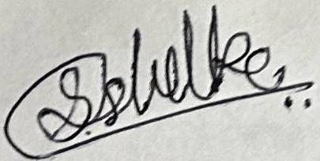

- (Sanika Atul Shelke)

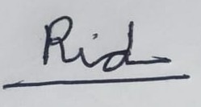
- (Ridhvik Rajesh Thakur)
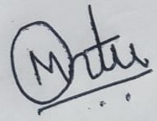

- (Montu Tagaram Suthar)

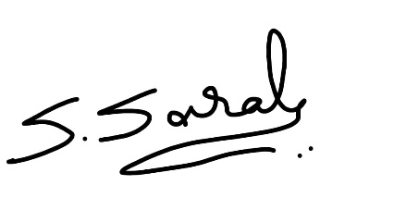

- (Sarla Marry)

Place: A. P. Shah Institute of Technology, Thane

Date: 02/07/2024

